Name__________________ Date ______
Solid Figures Pre-Assessment
Focus: Review
1. What is a solid figure?
a. A two-dimensional shape with no thickness.
b. A three-dimensional figure with length, width, and thickness.
c. A three-dimensional figure with no thickness.

2. Draw a line to match the solid figures with their proper names.

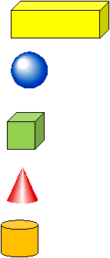

Cylinder

Sphere

Rectangular Prisim

Cone

Cube

3. A cube has…

________________ ________________ ________________
Faces Edges Vertices

4. Look the solid figure below. Circle the plane shapes that make up this solid figure.

Focus: Combine Solid Figures

5. True or false. We can combine solid figures to make different solid objects.
True False

6. Circle the solid figures below that can be stacked.

7. Which solid figures could not be easily stacked on top of each other?
a. A rectangular prism and a cube.
b. A cylinder and a cube.
c. A sphere and a cone.

8. Look at the solid object below. Circle the solid figures that make up this different solid object.
